APPLICATION NOTE
L298D Motor Drive Board

INTRODUCTION
This board is available from a number of suppliers, such as Amazon and eBay. The units bought for this Project were obtained from GearBest: (https://www.gearbest.com/other-accessories/pp_226466.html?wid=1433363).
Regardless of the source, they all appear to come from China. Gearbest was used because of the price (£1.15 at the time of purchase), but delievery took around 2 weeks.
This Application Note is being written to gather together all the information gleaned from various sources, because none of the Suppliers provide any documentation for this Module. The board utilises the L298D Dual Full Bridge Driver IC; hence the name of the Module.

GENERAL SPECIFICATIONS

General View of Device with Connectivity
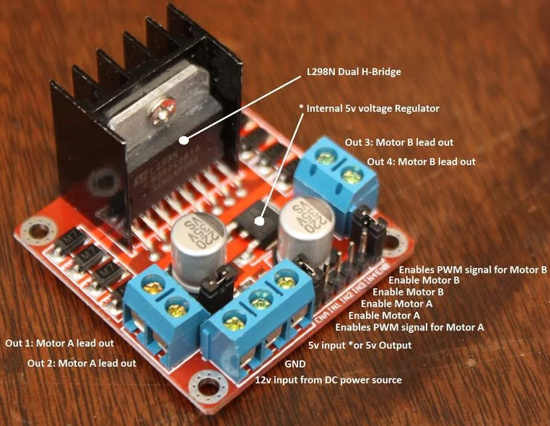
The specification below is for the device shown in the image below:

Specifications
- L298N Double H bridge Drive Chip
- Logical voltage - 5V Drive voltage: 5V-35V (Can work on 3.3 V)
- Logical current - 0-36mA Drive current: 2A
(MAX single bridge)
- Max power - 25W
- Dimensions - 43 x 43 x 26mm
- Weight - 26g

Pinouts:
- Out 1 - Motor A lead out
- Out 2 - Motor A lead out
- Out 3 - Motor B lead out
- Out 4 - Mo
- 12 V - 5 V to 35 V (marked as 12v)
- GND - Ground
- 5 V - 5 V input (unnecessary if power source is 7v-35v,
if the power source is 7 V to 35 V then it can act as a 5 V out.
(Output current is not published, so take care!))
- EnA - Enables PWM signal for Motor A
- In1 - Enable Motor A
- In2 - Enable Motor A
- In3 - Enable Motor B
- In4 - Enable Motor B
- EnB - Enables PWM signal for Motor B

L298D GENERAL DESCRIPTION
(Taken from the Datasheet)
The L298 is an integrated monolithic circuit in a 15-lead Multiwatt and PowerSO20 packages. It is a high voltage, high current dual full-bridge driver designed to accept standard TTL logic levels and drive inductive loads such as relays, solenoids, DC and stepping motors. Two enable inputs are provided to enable or disable the device independently of the input signals. The emitters of the lower transistors of each bridge are connected together and the corresponding external terminal can be used for the connection of an external sensing resistor. An additional supply input is provided so that the logic works at a lower voltage.

Key Parameters
- Input Low Voltage - -0.3 V t0 1.5 V
- Input High Voltage - 2.3 V to Vss

This means that Logic Inputs may be driven from the Raspberry Pi’s 3.3 V logic.

Block Diagram
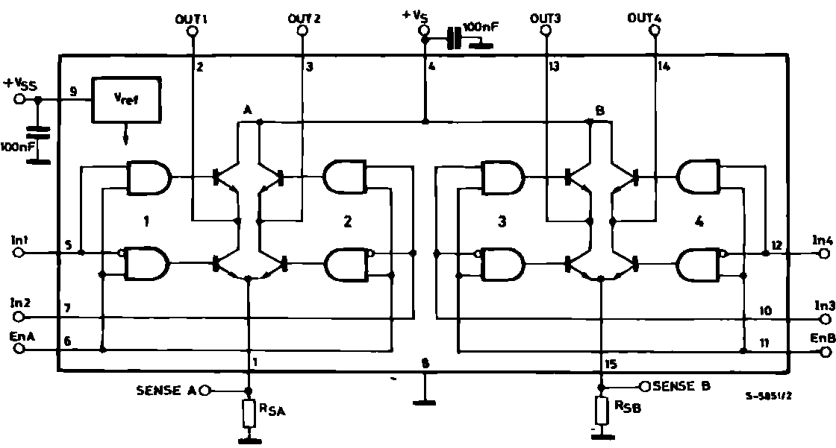

Motor Drive Application
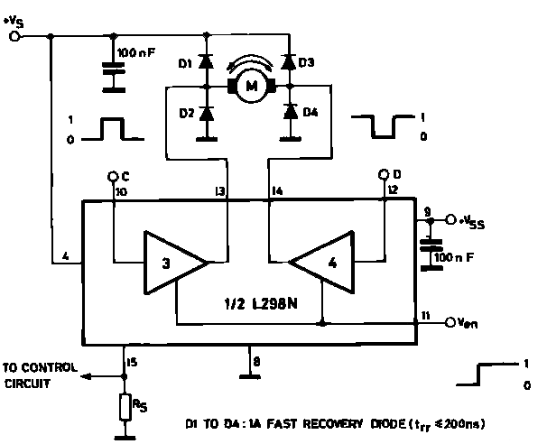
RIVER SYSTEM ACTUATOR MOTOR DRIVER - PRACTICAL CIRCUIT
